

A MINI PROJECT ON

**AUTONOMOUS DRONE FOR AUTOMATIC DELIVERY SYSTEM**

***Submitted to the***

# JAWAHARLAL NEHRU TECHNOLOGICAL UNIVERSITY KUKATPALLY, HYDERABAD

***In partial fulfilment of the requirement for the award of the degree of***

# BACHELOR OF TECHNOLOGY IN

**ELECTRONICS & COMMUNICATION ENGINEERING**

# BY

## Vishal Bakshi (187Y1A0455)

**P. Vamshi Krishna (187Y1A0451)**

**Under the Guidance of**

# Dr. G. AMARNATH

Associate Professor



## DEPARTMENT OF ELECTRONICS AND COMMUNICATION ENGINEERING



**MARRI LAXMAN REDDY**

**INSTITUTE OF TECHNOLOGY & MANAGEMENT**

Approved by AICTE-New Delhi, Accredited by **NBA** and **NAAC** with ‘**A**’ Grade Affiliated to JNTUH, Hyderabad and Recognized Under Section 2(f) & 12(b) of the UGC act, 1956

Dundigal (V), Quthbullapur (M), Medchal (D), Hyderabad, Telangana-500043

## March, 2020



**Department of Electronics & Communication Engineering**



**INSTITUTE OF TECHNOLOGY & MANAGEMENT**

Approved by AICTE-New Delhi, Accredited by **NBA** and **NAAC** with ‘**A**’ Grade Affiliated to JNTUH, Hyderabad and Recognized Under Section 2(f) & 12(b) of the UGC act, 1956

Dundigal (V), Quthbullapur (M), Medchal (D), Hyderabad, Telangana-500043

**MARRI LAXMAN REDDY**

Date:

**CERTIFICATE**

This is to certify that the project work entitled **“AUTONOMOUS DRONE FOR AUTOMATIC DELIVERY SYSTEM”** work done by **Vishal Bakshi (187Y1A0455) and P. Vamshi Krishna (187Y1A0451)** students of Department of Electronics and Communication Engineering, is a record of bonafide work carried out by the members during a period from June, 2021 to October, 2021 under the supervision of **Dr. G. Amarnath, Associate Professor**. This project is done as a fulfilment of obtaining **Bachelor of Technology** Degree to be awarded by **Jawaharlal Nehru Technological University Hyderabad, Hyderabad.**

The matter embodied in this project report has not been submitted by us to any other university for the award of any other degree.

Vishal Bakshi P.Vamshi Krishna

This is to certify that the above statement made by the candidates is correct to the best of my/our knowledge.

Date:

Name

Dr. G. Amarnath

The Viva-Voce Examination of above students, has been held on………………………………

Head of the Department Signature of External Examiner

Principal

ii

**ACKNOWLEDGEMENTS**

We would like to express my sincere gratitude to my guide **Dr. G. Amarnath**, **Associate Professor**, Department of Electronics and Communication Engineering, for his excellent guidance and invaluable support, which helped me accomplish the B.Tech (ECE) degree and prepared me to achieve more life goals in the future. His total support of my dissertation and countless contributions to my technical and professional development made for a truly enjoyable and fruitful experience. Special thanks are dedicated for the discussions we had on almost every working day during my project period and for reviewing my dissertation.

We are very much grateful to our Project Co-Ordinator**, Dr. G. Amarnath**, **Associate Professor,** Department of ECE, MLRITM, Dundigal, Hyderabad, who has not only shown utmost patience, but was fertile in suggestions, vigilant in directions of error and has been infinitely helpful.

We are extremely grateful to **Dr. Srinivas Bachu**, **Associate Professor & HOD- ECE**, MLRITM, Dundigal, Hyderabad, for the moral support and encouragement given in completing my project work.

We wish to express deepest gratitude and thanks to **Dr. K. Venkateswara Reddy, Principal,** MLRITM, for his constant support and encouragement in providing all the facilities in the college to do the project work.

We would also like to thank all our faculties, administrative staff and management of MLRITM, who helped me to completing the mini project.

On a more personal note we thank our **beloved parents and friends** for their moral support during the course of our project.

**TABLE OF CONTENTS**

|  |  |  |
| --- | --- | --- |
| *Certificate* |  | *ii* |
| *Acknowledgements* |  | *iii* |
| *Table of contents* |  | *iv* |
| *List of Figures* |  | *vi* |
| *List of Abbreviations* |  | *vii* |
| *Abstract* |  | *viii* |
| **Chapter 1** | **Introduction** | **1-13** |
|  | 1.1 Background and Motivation | 1-3 |
|  | 1.1.1 The History of Drones | 2 |
|  | 1.1.2 Modern Drone Technology | 2 |
|  | 1.1.3 Motivation | 3 |
|  | 1.2 Introduction to Drone Technology | 4-11 |
|  | 1.2.1 How Drones Work | 6 |
|  | 1.2.2 Technology Features and Components | 6 |
|  | 1.2.3 Types of Drones | 7 |
|  | 1.3 Conclusion | 11-12 |
|  | 1.4 Organization of Report | 12-13 |
| **Chapter 2** | **Literature Survey** | **14-19** |
|  | 2.1 Introduction | 14-15 |
|  | 2.2 Literature Review | 16-17 |
|  | 2.3 Conclusions | 18-19 |
| **Chapter 3** | **Methodology** | **20-31** |
|  | 3.1 Introduction | 20 |
|  | 3.2 Component Description | 21-25 |

|  |  |  |
| --- | --- | --- |
|  | 3.3 Methodology | 25-28 |
|  | 3.3.1 Working of Drones | 25 |
|  | 3.4 Hardware Working | 29-31 |
| **Chapter 4** | **Result and Discussion** | **32-40** |
|  | 4.1 Introduction | 32-34 |
|  | 4.1.1 Gazebo | 32 |
|  | 4.1.2 OBC Operation | 34 |
|  | 4.2 Analysis | 35-36 |
|  | 4.2.1 Simulator Explanation | 35-36 |
|  | 4.3 Application | 37-38 |
|  | 4.4 Advantages | 39 |
|  |  |  |
| **Chapter 5** | **Conclusion and Future Scope** | **40** |
|  | 6.2 Conclusion | 40 |
|  | 6.3 Future Scope | 40 |
|  | **References** | **41-42** |
|  | **Annexure** | **43-45** |

# LIST OF FIGURES

|  |  |  |
| --- | --- | --- |
| **Figure No.** | **Name of the figure** | **Page No** |
| Fig 1.1 | Multi rotor drone | 8 |
| Fig 1.2 | Fixed wing drone | 9 |
| Fig 1.3 | Single rotor copter | 10 |
| Fig 1.4 | VTOL drone | 11 |
| Fig 3.1 | Basic quadcopter | 20 |
| Fig 3.2 | Quadcopter model block diagram | 21 |
| Fig 3.3 | Flight controller | 24 |
| Fig 3.4 | Onboard computer | 25 |
| Fig 3.5 | Motor directions on frame | 26 |
| Fig 3.6 | Movement of drone | 28 |
| Fig 3.7 | Hardware working process | 29 |
| Fig 4.1 | Gazebo simulator | 32 |
| Fig 4.2 | Gazebo simulator with real world environment | 33 |
| Fig 4.3 | Initial pose of quadcopter | 35 |
| Fig 4.4 | Pick-up pose of quadcopter | 36 |
| Fig 4.5 | Delivery pose of quadcopter | 37 |
|  |  |  |

**LIST OF ABBREVIATIONS**

|  |  |
| --- | --- |
| UAV | Unmanned aerial vehicle |
| EKF | Extended Kalman filter |
| ROS | Robot operating system |
| IMU | Inertial measurement unit |
| SLAM | Simultaneous localization and mapping |
| GUI | Graphical user interface |
| FCU | Flight controller unit |
| OBC | On-board computer |
| GPS | Global positioning system |
| VTOL | Vertical take-off and landing |
| QC | Quadcopter |
| ESC | Electronic speed controller |
| ANN | Artificial neural networks |
| OS | Operating system |
| QGC | QgrounDController |
| UART | Universal Asynchronous Receiver/Transmitter |
| SPI | Serial Peripheral Interface |
| GPU | Graphic processing unit |

**ABSTRACT**

In the modern era, major companies like Amazon, Flipkart are implementing delivery of a product from place to place on a very large scale. Due to the heavy traffic issues faced by the delivery assistants all over the world, we have come up with a solution called autonomous navigated delivery using drones, where they carry the product from the warehouse to the destination of the buyer. Using ROS (Robot operating system) in Ubuntu kernel, we simulate and program the drone to autonomously hover from a place and travel to a distance with avoiding all the obstacles and land with accuracy. The purpose is to deliver the essentials between target locations autonomously; this can be achieved by using a autonomously navigating quadcopter. Thus, the project is is to navigate a quadcopter autonomously between target locations avoiding obstacles. The quadcopter is built with pixhawk running PX4 flight stack as FCU and Raspberry-pi with ROS installed as on-board computer. The process of delivery is executed and analysed using a gazebo simulator in which real world environment set-up can also be done. Thus, we can improve the working of the model by analysing and correcting the error before practical setup execution.

# CHAPTER 1 INTRODUCTION

## BACKGROUND AND MOTIVATION:

Unmanned Aerial Vehicle, or UAV, is the term most commonly used today to describe what the world has come to know as drones*.* UAVs can be controlled using a milieu of high-tech communication protocols like GPS and other satellite communications. UAVs can be remotely piloted by a human, team of humans, or a computerized piloting system. UAVs can also be fully autonomous. Autonomous UAVs are given instructions and then they take off, fly, carry out orders, and land. The Quadcopter is able to take off without a runway, be able to reach in difficult terrains, take a picture from a particular position and finally maneuver through tight spaces as required. The Quadcopter can also be used for sensing various climatic conditions such as heat, pressure and humidity in a foreign land. The Quadcopter also provides a superior payload capacity when compared to the helicopter and is a more stable platform. Other terms used to describe drones include remotely piloted aircraft, remotely operated aircraft, unmanned aircraft system, and just recently the Federal Aviation Administration adopted the term Unmanned Aircraft to describe aircraft without flight crew. The latest drones have dual Global Navigational Satellite Systems such as GPS. Highly accurate drone navigation is very important when flying especially in drone applications such as creating 3D maps, surveying landscape and Search & Rescue missions.

Quadcopters generally use two pairs of identical fixed pitch propellers; two [clockwise](https://en.wikipedia.org/wiki/Clockwise) and two [counterclockwise.](https://en.wikipedia.org/wiki/Counterclockwise) These use independent variation of the speed of each rotor to achieve control. By changing the speed of each rotor it is possible to specifically generate a desired total [thrust](https://en.wikipedia.org/wiki/Thrust); to locate for the [centre of](https://en.wikipedia.org/wiki/Centre_of_thrust) [thrust](https://en.wikipedia.org/wiki/Centre_of_thrust) both laterally and longitudinally; and to create a desired total [torque](https://en.wikipedia.org/wiki/Torque), or turning force. At a small size, quadcopters are cheaper and more due to their mechanical simplicity. Their smaller blades are also advantageous because they possess less kinetic energy, reducing their ability to cause damage. For small-scale quadcopters, this makes the vehicles safer for close interaction. It is also possible to fit quadcopters

with guards that enclose the rotors, further reducing the potential for damage. The different types of UAV are VTOL, fixed wing, multi-rotor. The most commonly used configurations are quad, hex and octal configurations.

## The History of Drones:

Many traces the history of drones to 1849 Italy, when Venice was fighting for its independence from Austria. Austrian soldiers attacked Venice with hot-air, hydrogen- or helium-filled balloons equipped with bombs. The first pilotless radio-controlled aircraft were used in World War I. In 1918, the U.S. Army developed the experimental Kettering Bug, an unmanned "flying bomb" aircraft, which was never used in combat.

The first generally used drone appeared in 1935 as a full-size retooling of the de Havilland DH82B "Queen Bee" biplane, which was fitted with a radio and servo- operated controls in the back seat. The plane could be conventionally piloted from the front seat, but generally it flew unmanned and was shot at by artillery gunners in training. The term drone dates to this initial use, a play on the "Queen Bee" nomenclature.

UAV technology continued to be of interest to the military, but it was often too unreliable and costly to put into use. After concerns about the shooting down of spy planes arose, the military revisited the topic of unmanned aerial vehicles. Military use of drones soon expanded to play roles in dropping leaflets and acting as spying decoys. Military drone use solidified in 1982 when the Israeli Air Force used UAVs to wipe out the Syrian fleet with minimal loss of Israeli forces. The Israeli UAVs acted as decoys, jammed communication and offered real-time video reconnaissance. Drones have continued to be a mainstay in the military, playing critical roles in intelligence, surveillance and force protection, artillery spotting, target following and acquisition, battle damage assessment and reconnaissance, as well as for weaponry.

* + 1. **Modern Drone History:** A Wall Street Journal report claims widespread drone use began in 2006 when the U.S. Customs and Border Protection Agency introduced UAVs to monitor the U.S. and Mexico border.

In late 2012, Chris Anderson, editor in chief of Wired magazine, retired to dedicate himself to his drone company, 3D Robotics, Inc. (3DR). The company, which started off specializing in hobbyist personal drones, now markets its UAVs to aerial photography and film companies, construction, utilities and telecom businesses, and public safety companies, among others.

In late 2013, Amazon CEO Jeff Bezos announced a plan to use commercial drones for delivery activities. However, in July 2016, Reno-based start-up Flirtey beat Amazon to the punch, successfully delivering a package to a resident in Nevada via a commercial drone. Other companies have since followed suit. For example, in September 2016, Virginia Polytechnic Institute and State University began a test with Project Wing, a unit of Google owner Alphabet, Inc., to make deliveries, starting with burritos produced at a local Chipotle restaurant. Then in December 2016, Amazon delivered its first Prime Air package in Cambridge, England. In March of 2017, it demonstrated a Prime Air drone delivery in California. Drone education is also expanding; Embry- Riddle Aeronautical University, long a training ground for the aviation industry, now offers a Bachelor of Science in unmanned systems applications, a Master of Science in unmanned systems and an undergraduate minor in unmanned aerial systems.

## Motivation:

Transportation plays vital roles in lives. Its connections are associated with almost everything, from postal deliveries to multi-million cargo shipments. Currently, transportation of medical goods during critical need is limited to wheeled motor vehicles and manned aircrafts, which can be costly, slow, and sometimes impossible when emergency site is out of reach. Whenever a medical emergency occurs, quick response time is critical in terms of life saving. Furthermore, traffic congestion is a major problem in big cities and ambulances can be stuck in a traffic jam and may not be able to arrive within the targeted emergency response time. Drones can be seen as the innovative alternatives in enabling immediate help to victims suffering from health emergencies or traffic accidents before professional medical personnel arrive. By speeding up emergency response, possible harms can be avoided and healthcare providers can prevent potential deaths and accelerate patient treatment.

Nowadays, drones revolutionize the healthcare by transporting lifesaving medical equipment and supplies such as medical first aid kits, telemedicine or medical support such as diagnostics, drugs, or tools, blood, life-saving drugs, vaccines or anti-venom, defibrillators to patients in cardiac arrest, prescriptions and even organs for transplantation. Drones are also capable of delivering medical supplies quickly and effectively to people in remote medical centers, disaster areas, and offshore vessels. Thus, as stated in Scott and Scott (2017), drones are useful for medical supplies delivery when the delivery involves small items, remote locations with difficult access, timely delivery, poor transportation infrastructure at destination, or roads blocked by severe weather, disasters or traffic congestion. Thus, a QC can be used as weight lifter which is capable of making a path using Global Positioning System for delivering parcel.

## INTRODUCTION TO DRONE TECHNOLOGY:

A drone of a UAV typically refers to a pilotless aircraft that operates through a combination of technologies, including computer vision, artificial intelligence, object avoidance technology, and others. But drones can also be a ground or air vehicles that operate autonomously. Quadcopters have been the most popular flying machine so far. Its flight is controlled either autonomously by onboard computers or by the remote control of a pilot on the ground or in another vehicle. The QC an emerging UAV is lifted and propelled by four motors. The motors and propellers are the drone technology, which move the UAV into the air and to fly in any direction or hover. They receive data from flight controller and electronic speed controllers on the drone motor direction to either hover or fly. QC has good maneuverability with limitless applications. Departing from a century old design, modern QCs are evolving into small and agile vehicles. After already proving their usefulness as aerial imaging tools, new research is allowing QC to communicate perceptively with other autonomous vehicles, to explore unknown environments and to maneuver in dense surroundings with speed and precision. Individually, these advances will allow QC to complete missions such as long-term surveillance and search and rescue. However, if all of these developing technologies are combined, quad rotors will be capable of advanced autonomous missions that are currently not possible with any other vehicle. Drones are equipped with different state of the art technology such as infrared

cameras, GPS and laser. Drones are controlled by remote ground control systems which are also referred as a ground cockpit. A UAV system as two parts, the drone itself and the control system. Mainly Drone is an automated device which has a ground based controller and a system of communication between them. Among various kind of drone, Quadcopter is one of them. Mainly quadcopter is the type of multirotor helicopter that is lifted and propelled by four rotors. This type of drones generally contains two clockwise and two counterclockwise fixed pitched propellers. Mainly Quadcopter is used for performing tasks that are dangerous or very costly for humans. The risky and dangerous tasks like inspection of high structures, search-and- rescue missions in remote area quadcopter are usually the best option. The quadcopter design with four-rotor allows this to be relative in simple design yet highly reliable and maneuverable. According to the estimation of wind disturbances on a quadrotor unmanned vehicle and correction without sensors are helping to formulate a complete aerodynamic model of the quadrotor.

Use of autonomous QC will enable faster transport of goods which will ensure timely delivery. It will also reduce the fuel cost of vehicles and human labor of home delivery. Besides, it will improve transportation management. Generally, home delivery requires vehicle and manpower. This process consumes fuel of vehicle and time of service delivery boy. If the vehicle gets stucked to traffic jam then it will waste more time and fuel. Using an autonomous QC for home delivery can overcome this problem. Company’s operational efficiencies and productivity will increase as a result of improving supply chain management. It will help to increase customers’ satisfaction. Revenue growth is directly impacted by better supply chain management. Profitability and capital utilization also impacted by better supply chain management. Needless to say, better supply chain management ultimately helps one’s company to create a competitive advantage in market place. The effect of reducing fuel cost and labor cost will reduce production cost and increase consumer surplus and raise profit of the producer. Over the past few years, a growing ecosystem of ag-specific drone solutions has emerged, making it possible to put aerial data to work in new and exciting ways, ranging from detecting crop damage to analyzing stand counts. Drone technology is a phenomenal innovation that continues to have far- reaching effects across today’s society, transforming our lives and the way we do business.

UAVs typically fall into one of six functional categories:

* Target and decoy – providing ground and aerial gunnery a target that simulates an enemy aircraft or missile
* Reconnaissance – providing battlefield intelligence
* Combat – providing attack capability for high-risk missions.
* Logistics – delivering cargo
* Research and development – improve UAV technologies
* Civil and commercial UAVs – agriculture, aerial photography, data collection.

## How Drones Work:

* + - * While drones serve a variety of purposes, such as recreational, photography, commercial and military, their two basic functions are flight and navigation.
      * To achieve flight, drones consist of a power source, such as battery or fuel, rotors, propellers and a frame. The frame of a drone is typically made of lightweight, composite materials, to reduce weight and increase maneuverability during flight.
      * Drones require a controller, which is used remotely by an operator to launch, navigate and land it. Controllers communicate with the drone using radio waves, including Wi-Fi.

## Technology, Features and Components:

Drones contain a large number of technological components, including:

* Electronic Speed Controllers, an electronic circuit that controls a motor’s speed and direction.
* Flight controller
* GPS module
* Battery
* Antenna
* Receiver
* Cameras
* Sensors, including ultrasonic sensors and collision avoidance sensors
* [Accelerometer](https://whatis.techtarget.com/definition/accelerometer), which measures speed
* Altimeter, which measures altitude

## Types of Drones:

“Drones” can be classified on a different basis – say based on ‘***usage*** ‘like Drones for Photography, Drones for aerial Mapping, Drones for Surveillance etc. However, the best classification of ‘Drones’ can be made on the basis of aerial platforms. Based on the type of aerial platform used, there are 4 major types of drones.

1. Multi Rotor Drones: Multi Rotor drones are the most common types of drones which are used by professionals and hobbyists alike. They are used for most common applications like aerial photography, aerial video surveillance etc. Different types of products are available in this segment in the market – say multi- rotor drones for professional uses like aerial photography and there are lots of variants for hobby purposes like amateur drone racing, or leisure flying. Out of all the 4 drone types, multi-rotor drones are the easiest to manufacture and they are the cheapest option available as well.

Although easy to manufacture and relatively cheap, multi-rotor drones have many downsides. The prominent ones being it’s limited flying time, limited endurance and speed. They are not suitable for large-scale projects like long distance aerial mapping or surveillance. The fundamental problem with the multicopters is they have to spend a huge portion of their energy possibly from a battery source just to fight gravity and stabilize themselves in the air. At present, most of the multi-rotor drones out there are capable of only a 20 to 30 minutes flying time often with a minimal payload like a camera

Multi-rotor drones can be further classified based on the number of rotors on the platform. They are Tricopter-3 rotors, Quadcopter-4 rotors, Hexacopter-6 rotor and Octocopter-8 rotors. Out of these, Quadcopters are the most popular and widely used variant.

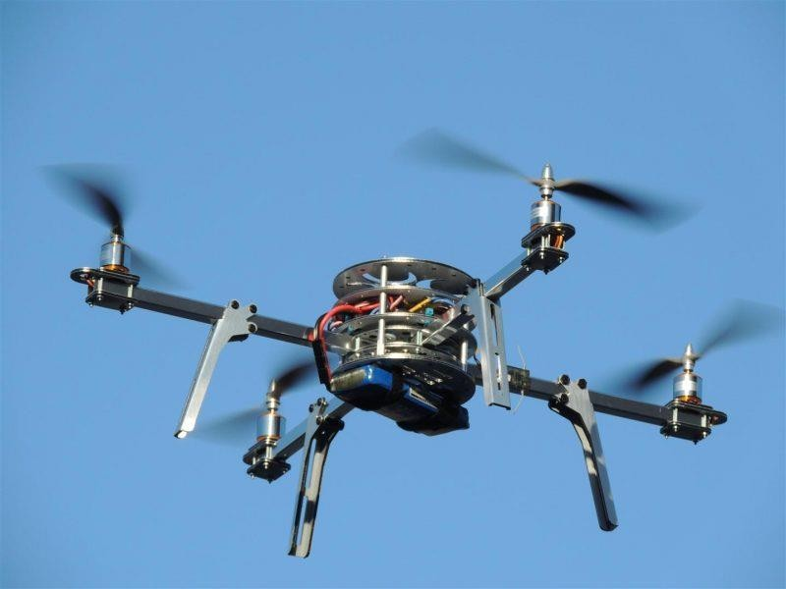

**Fig 1.1** Multi rotor drone

1. Fixed Wing Drones: Fixed Wing drones are entirely different in design and build to multi-rotor type drones. They use a ‘wing’ like the normal airplanes out there. Unlike multi-rotor drones, fixed wing type models never utilize energy to stay afloat on air as fixed wing types can’t stand still on the air for fighting gravity. Instead, they move forward on their set course or as set by the guide control as long as their energy source permits. Most fixed wing drones have an average flying time of a couple of hours. Gas engine powered drones can fly up to 16 hours or higher. Owing to their higher-flying time and fuel efficiency, fixed wing drones are ideal for long distance operations be it mapping or surveillance. But they cannot be used for aerial photography where the drone needs to be kept still on the air for a period of time. The other downsides of fixed-wing drones are higher costs & skill training required in flying. It’s not easy to put a fixed wing drone in the air. You either need a ‘runway’ or a catapult launcher to set a fixed wing drone on its course in the air. A runway or a parachute or a net is again necessary to land them back in ground safely. On the other side, multi-rotor drones are cheap – anyone with a few hundred dollars to spare can buy a decent quadcopter. Flying a

quadcopter doesn’t require special training. You just take them to an open area and fly it. Guiding and controlling a quadcopter can be learned on the go.

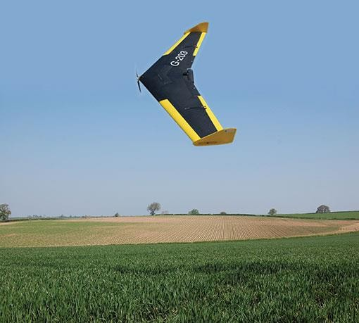

**Fig 1.2** Fixed wing drone

1. Single Rotor Helicopter: Single rotor drones look very similar in design & structure to actual helicopters. Unlike a multi rotor drone, a single rotor model has just one big sized rotor plus a small sized one on the tail of the drone to control its heading. Single rotor drones are much efficient than multi rotor versions. They have higher flying times and can even be powered by gas engines. In aerodynamics, the lower the count of rotors the lesser will be the spin of the object. And that’s the big reason why quadcopters are more stable than octocopters. In that sense, single rotor drones are much efficient than multi-rotor drones. However, these machines come with much higher complexity and operational risks. Their costs are also on the higher side. The large sized rotor blades often pose a risk fatal injury have been recorded from rc copter accidents if the drone is mishandled or involves in an accident. Multi-rotor drones, often owing to their small rotor blades have never been involved in fatal accidents though a scar on

human body is likely. They also demand special training to fly them on air properly though they may not need a runway or a catapult launcher to put them on air.

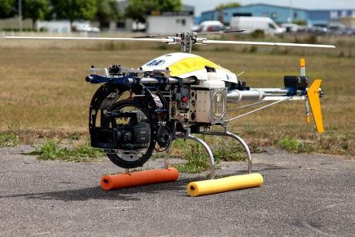

**Fig 1.3** Single rotor copter

1. Fixed Wing Hybrid VTOL: These are hybrid versions combining the benefits of Fixed wing models which has higher flying time with that of rotor-based models hover. This concept has been tested from around 1960’s without much success. However, with the advent of new generation sensors which are gyros and accelerometers, this concept has got some new life and direction. Hybrid VTOL’s are a play of automation and manual gliding. A vertical lift is used to lift the drone up into the air from the ground. Gyros and accelerometers work in automated mode i.e autopilot concept to keep the drone stabilized in the air. Remote based or even programmed, manual control is used to guide the drone on the desired course.

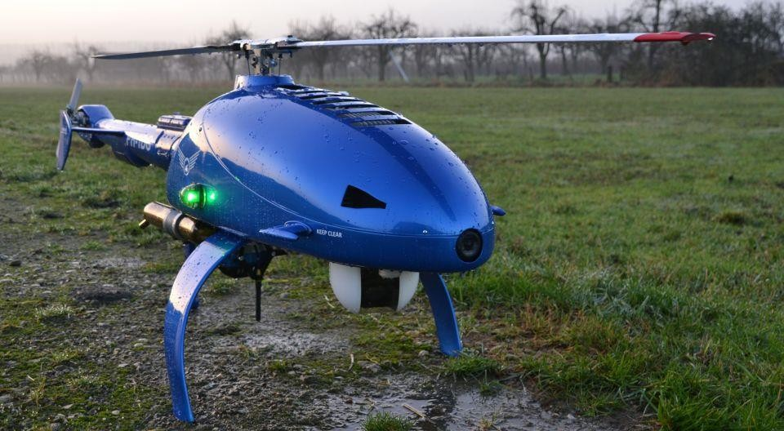

**Fig 1.4** VTOL drone

## CONCLUSION:

In our project, to make the Quadcopter autonomous, we used Pixhawk platform to program and utilized mission planner software to generate the flight plan of the quadcopter by using input values from GPS and sensors. An Inertial Measurement Unit sensor which provides values regarding angles and angular velocities of quad copter frame is utilized to obtain flight characteristics. The components are assembled together and rigorous testing is done under different environment conditions to tune the flight controller for successful flight. In case of remote-controlled drone, there might be a chance of damage in transmission section which would result in loss of control over the flight which in turn may lead to catastrophe. While a manned aerial vehicle puts the pilots at risk during the crash, a UAV is able to fly anywhere even into the zones where it would be dangerous for the pilot. Unmanned aerial vehicle technology covers everything from the aerodynamics of the drone, materials in the manufacture of the physical UAV, to the circuit boards, chipset and software, which are the brains of the drone. One of the most popular drones on the market is the DJI Phantom 3. This drone was very popular with professional aerial cinematographers.

While slightly old now, it uses plenty of advanced technology which is present in the very latest drones.

Mainly Drone is an automated device which has a ground-based controller and a system of communication between them. Among various kind of drone, Quadcopter is one of them. Mainly quadcopter is the type of multirotor helicopter that is lifted and propelled by four rotors. This type of drones generally contains two clockwise and two counterclockwise fixed pitched propellers. A proper UAV design process has to be started with detailed payload specification, desired performance, endurance and other important parameters. In order to finish initial design assumptions and select suitable platform a methodology was harnessed. This UAV is ideal to explain drone technology because it has everything in one package. It includes the UAV and camera and uses some of the top drone technology on the market today. Drones come in a wide variety of sizes, with the largest being mostly used for military purposes such as the [Predator drone.](https://youtu.be/jrlxLEiYplE) The next in size are unmanned aircraft, which have fixed wings and require short runways. These are generally used to cover large sections of land, working in areas such as geographical surveying or to combat wildlife poaching.

## ORGANISATION OF REPORT:

The project outline is organized as follows:

## Chapter 1:

Chapter 1 shows the introduction, motivation and objective of our project.

## Chapter 2:

In chapter 2, the literature survey is organized.

## Chapter 3:

The working methodology of the quadcopter and its components is explained in chapter 3.

## Chapter 4:

We discussed about the results and their analysis along with their applications and advantages.

## Chapter 5:

In chapter 5, we discussed about the conclusions and future scope of autonomous navigation of a quadcopter.

## CHAPTER 2

**LITERATURE SURVEY**

## INTRODUCTION:

Autonomous navigation of drones continues to be a very broad field of research in which different methods have been proposed, using technologies such as geolocation and artificial vision. This work presents a method that combines artificial vision techniques and artificial neural networks to achieve the autonomous landing of a quadcopter based on references obtained by detecting and locating a helipad near the end point of its programmed path. This method lets the system be independent from GPS data by using a control based on visual characteristics in the last flight stage instead. Images from a camera mounted on the quadcopter will be used to locate the helipad. Later, two artificial neural networks will operate in cascade to identify the marker and determine its position. This information will allow the drone to locate itself on the helipad and update its landing routine autonomously. Additionally, the Lucas Kanade optical flow predictor has been implemented to track the marker as a function of the strong characteristics obtained from the region of interest delivered by the ANN. This process is performed with the aim of reducing the computational cost of the proposed method and improving its execution time. To validate the proposed method, flight tests were carried out in which the landing point was to be located in various types of terrain, achieving 70 percent of success on highly roughened surfaces and 100 percent in homogeneous surfaces. An Unmanned Aerial Vehicles an air-craft without a human pilot aboard. Its flight is controlled either autonomously by onboard computers or by the remote control of a pilot on the ground or in another vehicle. The QC an emerging UAV is lifted and propelled by four rotors. It has good maneuverability with limitless applications. Departing from a century old design, modern QCs are evolving into small and agile vehicles. After already proving their usefulness as aerial imaging tools, new research is allowing QC to communicate perceptively with other autonomous vehicles, to explore unknown environments and to maneuver in dense surroundings with speed and precision. Individually, these advances will allow QC to complete missions such as longterm surveillance and search and rescue. However, if all of these developing technologies are combined,

quad rotors will be capable of advanced autonomous missions that are currently not possible with any other vehicle. This paper shows details and usages of a QC as weight lifter which is capable of making a path using Global Positioning System for delivering parcel ordered by online. A typical digital aerial or UAV photogrammetry process is an offline, sequential process, based on data processing separated in time and location from measurement. Data are gathered in one time, downloaded form a camera data storage and passed to a photogrammetry station, which now is a relevant PC with photogrammetry software. If for some reason and applications a fast data gathering and processing is crucial and desired, an online photogrammetry can be engaged. Various technologies have been developed in the field of artificial intelligence, trying to facilitate human life and performing complex analysis processes in situations where conventional control systems are not feasible to implement. Also, the use of artificial vision systems has improved life quality through the complex analysis of images and its use in different applications. Another technological element booming with a great application potential are the unmanned autonomous vehicles or drones. A drone is considered as a multicopter if it has three or more propellers arranged in a plane and without owning a tail rotor. Currently, these devices are mainly used in the civil field, because of the advantages they provide, such as flight stability, speed control of each motor and relatively inexpensive and simple mechanism. The solution of the problems of optimal control of aircraft-type drones is considered on the basis of the synthesis method with the predictive model in accordance with the criterion of the generalized work of A.A. Krasovsky. An analytical expression is obtained for the control law of a nonlinear dynamic object with variable control efficiency. The approximation of a single mass point under conditions of applied forces causes motion in atmosphere layers integral force of head resistance, integral lift force, integral force of head roll-out is used as a mathematical model of a drone. In the synthesis of optimal control, natural forces are imposed on these forces, due to the aerodynamic laws of flow around the drone. Due to the combination of the point model and the forces applied to this point, an analytical expression for the control law is obtained, in spite of the nonlinearity of the drone equations. Synthesized controls permit to solve the problems of terminal management which is a very important condition in the control of the drone planting

## LITERATURE REVIEW:

GPS data can become faulty under bridges, inside tunnels, or near high-voltage power lines, which could lead to drone flight errors. To address this issue, we are developing a system for conducting infrastructure inspections using drones that basically use GPS for autonomous flight control, but can also estimate self-position through image processing when GPS cannot be used under situations such as those mentioned above. This paper describes a method for estimation of self-position using ground images, with the aim of developing an autonomous drone flight system for use in infrastructure inspection. In cases when GPS data cannot be used, autonomous flight similar to GPS navigation is still possible as long as the absolute position coordinates and the relative moving distance of the drone are known. Therefore, used ground images directly underneath the drone to estimate self-position. In particular, the method involves detecting feature points from a ground image sequence, estimating camera position and attitude, as well as mapping. In this study, we refer to this system as “ground- image gyro.”

The signals calculated were used to send the control actions when the autonomous mode is active. A system for switching between the original signals sent by the Turnigy 9X transmitter and similar ones generated by the Arduino MEGA 2560 board has also implemented in order change the operation mode from manual control (human operator) to autonomous control by means of the signals created by the artificial vision algorithm.

1. Height Reading This subroutine allows knowing how high the multirotor is with reference to the ground, it remains active throughout the process to enable access to this data at any required time.
2. Take-off the take-off process has been established by controlling the pulse train of channel 3, which has control on the Z axis, allowing the aircraft to rise or fall as required. An active time value has been set to 1532 μs corresponding to the 60% acceleration of the total available to the quadcopter. This value was obtained by experimental tests in manual mode, observing the stick activation percentage of the acceleration channel, until getting the aircraft to take off without problems.
3. Height Control After takeoff, this sub-routine is responsible for keeping the aircraft throttle value in an active time value of 1450 μs when it reaches the height set point, which is 2500 mm (2.5m). This means that the motors will keep rotating at the same constant speed and the multirotor will not increase or decrease its height, thanks to the internal PID NAZA M Lite flight controller. When this action is executed, the previous subroutine is deactivated.
4. GPS Path tracking Once height control is established, the Arduino MEGA 2560 board compares the current multirotor position and the target landing zone position to calculate the distance (error) both in latitude (X) and length (Y), allowing the movement of the multirotor in the roll and pitch axes, using the times in high and low state of the PWM. For this task, a value of 20% of acceleration of each channel was stabilized.
5. Communication with the neural network When the GPS path is completed, access to the computer control is enabled through the neural network programmed in Visual Studio. The Arduino MEGA 2560 sends a code that activates the neural network search in order to locate the helipad by means of image identification. Then, the network positions the multirotor on the helipad and when the position is correct, another code is sent from the computer, which activates the landing sequence.
6. Landing sequence When the multirotor has approached the helipad previously identified, and the error distance on the neural network screen has an error smaller than 35 pixels, the neural network sends a code from the computer, which executes the autonomous landing sequence by means of the active time control of the accelerator, with a value of 1399 μs, corresponding to the 44% of acceleration, obtained from experimental tests in manual mode. Once this sequence has been executed, the communication with the neural network is deactivated and the values of roll and pitch channels remain in their medium values to achieve a sharp vertical descent, so when the ultrasonic sensor detects a height less than 30 mm the motors will be shut down, completing the process

## CONCLUSION:

Engineering and especially mechatronics is based on the use of mechanical elements, governed by electronic components that control the essential variables of the system, that is why it was decided to carry out this paper. This, because several studies show that landing is one of the most crucial stages of the flight of a UAV, and from this necessity, it was proposed to develop a tool of aid, able to control the variables of flight and landing in function of a pattern, in order to reduce the accidents that UAVs could suffer. Also, the use of artificial vision systems facilitates the analysis of much larger regions and focus on the specific search of an object or pattern, making, a traditional camera become a powerful environment analysis with these techniques. The algorithm developed made it possible to correctly identify the helipad, but at the beginning the main inconvenient was to determine the exact pattern location in the image. Therefore, it was necessary to implement another artificial neural network that gets information provided by its predecessor to help in the control of the flight variables, which substantially improved the control and positioning of the drone; but as a negative point was the latency of the system, caused by the amount of computational cost to be performed by the system processor. A predictor of optical flow that is fed in turn from the output of the second neural network that is on cascade was included, so that, once the object and its possible location are determined, Lucas Kanade predicts where the helipad will be, helping the controller and disabling the stages of the networks, for which the computational cost is minimal, being ideal for this to be processed by an onboard PC. It can be concluded that using ANN in cascades for solve complex challenges is possible but it is not efficient, for this reason it was necessary to include a predictor and deactivate the continuous search of the ANN when an object was recognized. This permits the robust and lightweight algorithm to be mounted on a modest computer pc. This, together with the unmanned aerial vehicles that are becoming more common to execute daily activities of security, package delivery or analysis of specific regions, have made possible to see that robust control tools are needed. The focus of this paper was to identify a landing point, in this case a helipad, and helping the drone in the lading stage. In order to successfully recognize the helipad pattern within the image, it was necessary to create a database with images of helipads that allow it to successfully train the ANNs and obtain a very robust recognition and tracking. All components discussed above must be merged in

different ways to solve specific problems; the project was successfully solved and shows that the use of ANNs allows finding complex objects in fairly structured environments.

# CHAPTER 3 METHODOLOGY

## INTRODUCTION:

A Quadcopter, also called a Quadrotor helicopter, is a multirotor helicopter that is lifted and propelled by four rotors. Unlike most helicopters, Quadcopters use 2 sets of identical fixed pitched propellers, 1st set consists of 2 clockwise and 2nd set consists of 2 counter-clockwise. These use variation of Revolutions Per Minute to control lift and torque. To maintain balance the Quadcopter must be continuously taking measurements from the sensors i.e. Gyroscope and Accelerometer, and making adjustments to the speed of each rotor to keep the body level. These adjustments are done by a sophisticated control system like Arducopter, Pixhawk on the Quadcopter in order to stay perfectly balanced. A Quadcopter has four controllable degrees of freedom: Yaw, Roll, Pitch, and Altitude. Each degree of freedom can be controlled by adjusting the thrusts of each rotor.

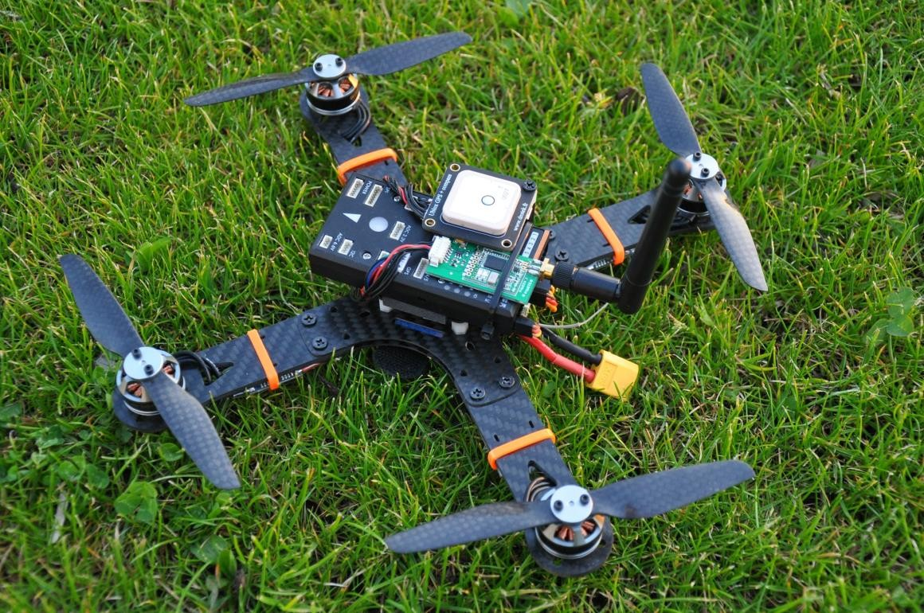

**Fig 3.1** Basic Quadcopter

Quadcopters are classified as rotorcraft, as opposed to fixed-wing aircraft, because their lift is generated by a set of rotors. Quadcopter configurations were seen as possible solutions to some of the problems in vertical flight. Mostly there are two types of Quadcopter configurations. First configuration is plus ‘+’ and the second configuration is cross. Quadcopters use an electronic control system and electronic sensors like Electronic Speed Controllers to stabilize the aircraft. With their small size, these Quadcopters can be flown indoors as well as outdoors. The use of four rotors allows each individual rotor to have a smaller diameter than the equivalent helicopter rotor. Due to this every motor has to carry 1/4th of the weight of Quadcopter as opposed to Helicopter where the single motor carries the whole weight. This increases the efficiency and life of motors. Some small-scale Quadcopters have frames that enclose the rotors, permitting flights through more challenging environments, with lower risk of damaging the vehicle or its surroundings.



TRANSMITTER

MOTOR 4

BATERRY

MOTOR 2

RECEIVER

ESC 2

ESC 4

ESC 3

PIXHAWK

ESC 1

MOTOR 3

MOTOR 1

SENSORS

TELEMETRY

GPS

## COMPONENT DESCRIPTION:

**Fig 3.2** Quadcopter Model Block Diagram

**Frame:** There are two possibilities when it comes to a frame for your drone. You can make it yourself or buy it in an online store, and for a wide choice of high-quality frames, we suggest checking out [our article about best drone frames](https://www.mydronelab.com/accessories/quadcopter-frames.html). If you decide to build it yourself, the project is not that difficult, but you’ll need some engineering knowledge and knowledge of the materials you are going to use. For instance, you can use metal (something light), plastic, or even wood slats. If you opt for a wooden frame, you’ll need a wood board which is about 2.5 cm thick.

**Motor:** Motors are a bit similar to normal DC motors in the way that coils and magnets are used to drive the shaft. They are two kinds of motors brushed motors and brushless motors. As the motors do not have a brush on the shaft which takes care of switching the power direction in the coils, and so it is called as brushless motors. Instead, the brushless motors have three coils on the inner of the motor, which is fixed to the mounting. For a small-scale Quadcopter, the DC Brushless motor used is of 1000 KV rating. It operates at 7.4-14.8 volts. A brushed DC motor has permanent magnets on the outside of its structure, with a spinning armature on the inside. In brushless DC motors, the permanent magnets are on the rotor, and the electromagnets are on the stator. A computer then charges the electromagnets in the stator to rotate the rotor a full 360-degrees. For industrial applications, brushless DC motors are primarily used in servo, actuation, positioning, and variable speed applications where precise motion control and stable operation are critical for the satisfactory operation of the manufacturing or industrial process. They are commonly used as Linear motors.

**ESC:** The brushless motors are multi-phased, normally 3 phases, so direct supply of DC power will not turn the motors on. That is where the Electronic Speed Controllers comes into play. The ESC generating three high frequency signals with different but controllable phases continually to keep the motor turning. The ESC is also able to source a lot of current as the motors can draw a lot of power.

At any one time, each of your motors could be spinning at different speeds. This is what lets you maneuver and change direction. It’s all conducted by the Electronic Speed Controls, so they’re very important.

**Propellers:** On each of the brushless motors there are mounted a propeller. The 4 propellers are actually not identical the motor torque of and the law of physics will

make the Quadcopter spin around itself if all the propellers were rotating the same way, without any chance of stabilizing it. The larger diameter and pitch the more thrust the propeller can generate. It also requires more power to drive it, but it will be able to lift more weight.

**Battery:** The power source for the whole device. The recommended battery is LiPo- Lithium Polymer battery because of it is light weighted in nature. LiPo batteries, short for Lithium Polymer battery, are a type of rechargeable battery that has taken the electric RC world by storm, especially for planes, helicopters, and multi-rotor/drone. They are the main reason electric flight is now a very viable option over fuel powered models. Lithium Polymer batteries henceforth referred to as “LiPo” batteries, are a type of battery now used in many consumer electronics devices. They have been gaining in popularity in the radio control industry over the last few years, and are now the most popular choice for anyone looking for long run times and high power. LiPo batteries offer a wide array of benefits, but each user must decide if the benefits outweigh the drawbacks. For more and more people, they do. In my personal opinion, there is nothing to fear from LiPo batteries, so long as you follow the rules and treat the batteries with the respect they deserve.

**Flight Controller**: The Flight Control Board is the “commander of operations”. It controls the accelerometer and gyroscopes, which control how fast each motor spins. The flight controller is Pixhawk. Pixhawk is an independent open-hardware project that aims to provide the standard for readily-available, high-quality and low-cost autopilot hardware designs for the academic, hobby and developer communities. Pixhawk supports multiple flight stacks: PX4 and ArduPilot. PX4 is an open source autopilot system oriented toward inexpensive autonomous aircraft. Low cost and availability enable hobbyist use in small remotely piloted aircraft. The project started in 2009 and is being further developed and used at Computer Vision and Geometry Lab of ETH Zurich and supported by the Autonomous Systems Lab and the Automatic Control Laboratory. Several vendors are currently producing PX4 autopilots and accessories. An autopilot allows a remotely piloted aircraft to be flown out of sight. All hardware and software is open source and freely available to anyone under a BSD license. Free software autopilots provide more flexible hardware and software. Users can modify the autopilot based on their own special requirements.

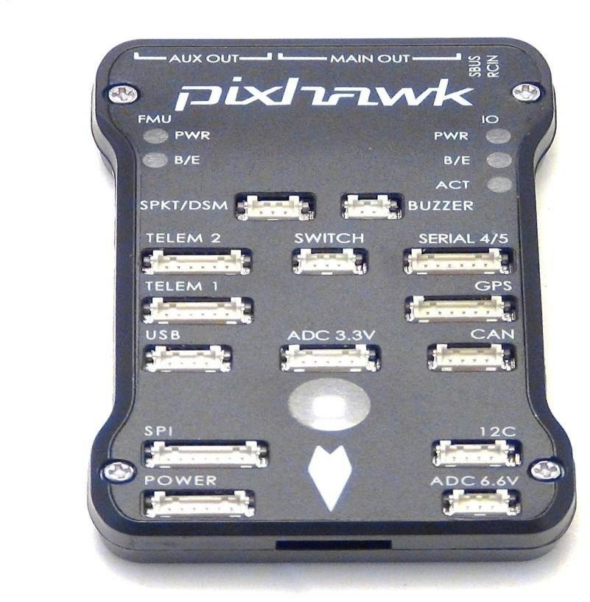

**Fig 3.3** Flight Controller

**RASPBERRY Pi:** The Raspberry Pi is a low cost, credit-card sized computer that plugs into a computer monitor or TV, and uses a standard keyboard and mouse. The Raspberry Pi primarily uses Linux kernel based operating systems. It is used for providing an IDE for writing Python scripts and hence generating inputs to be fed to the Flight Controller.

It is a capable little device that enables people of all ages to explore computing, and to learn how to program in languages like Scratch and Python. It is capable of doing everything you would expect a desktop computer to do, from browsing the internet and playing high-definition video, to making spreadsheets, word-processing, and playing games. The raspberry Pi has the ability to interact with the outside world, and has been used in a wide array of digital maker projects, from music machines and parent detectors to weather stations and tweeting birdhouses with infra-red cameras.

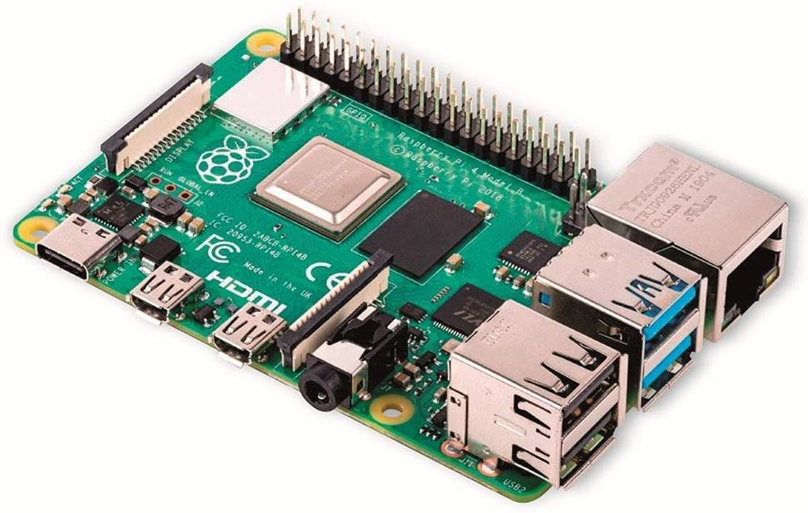

**Fig 3.4** On Board Computer

The Raspberry Pi is the OBC of the UAV, it acts as a mini computer with linux OS installed in it. It acts as the interface between the drone and the pilot. All the commands which need to be executed by the drone will be run over OBC. It also gives the position data of drone to the user, thus helps in tracking the autonomous vehicle.

## METHODOLOGY:

* + 1. **Working of Drones:**

A frame / drone chassis is built first before anything else is done. The choice of motors and other components specify the type of frame we will use. The frame considered here is F450 frame of X or + shape. Motors are set first on the frame.

**Vertical Motion:** Drones use rotors for propulsion and control. It is same as a rotor of a fan, because they working is the same. Spinning blades push air down. Of course, all forces come in pairs, which means that as the rotor pushes down on the air, the air pushes up on the rotor. This is the basic idea behind lift, which comes down to controlling the upward and downward force. The faster the rotors spin, the greater the lift, and vice-versa.

Now, a drone can do three things in the vertical plane: hover, climb, or descend. To hover, the net thrust of the four rotors pushing the drone up must be equal to the gravitational force pulling it down. Moving up, which pilots call as climbing, is just [increasing the thrust](https://www.wired.com/2014/05/modeling-the-thrust-from-a-quadcopter/) /speed of the four rotors so that there is a non-zero upward

force that is greater than the weight. After that, with decrease the thrust a little bit—but there are now three forces on the drone: weight, thrust, and air drag. So, it still needs for the thrusters to be greater than for just a hover. Descending requires doing the exact opposite: Simply decrease the rotor thrust /speed so the net force is downward.

## Turning /Rotating:

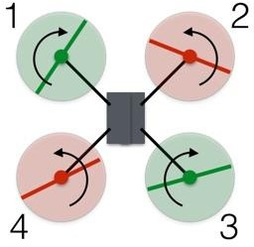

**Fig 3.5**: Motor directions on frame.

In this configuration, the red rotors are rotating counter clockwise and the green ones are rotating clockwise. With the two sets of rotors rotating in opposite directions, the total angular momentum is zero. [Angular momentum](https://www.wired.com/2017/05/the-phyiscs-of-fidget-spinners/) is a lot like linear momentum, and is calculated by multiplying the angular velocity by the moment of inertia. The moment of inertia is similar to the mass, except it deals with rotation. The angular momentum depends on how fast the rotors spin. If there is no torque on the drone, then the total angular momentum must remain constant, zero in this case. The red counter clockwise rotors have a positive angular momentum and the green clockwise rotors have a negative angular momentum. Let’s assign each rotor a value of +2, +2, -2, -2, which adds up to zero.

Let's say, want to rotate the drone to the right. Suppose the decrease in angular velocity of rotor 1 such that now it has an angular momentum of -1 instead of -2. If nothing else happened, the total angular momentum of the drone would now be +1. So, the drone rotates clockwise so that the body of the drone has an angular momentum of -1.

Decreasing the spin of rotor 1 indeed cause the drone to rotate, but it also decreased the thrust from rotor 1. Now the net upward force does not equal the gravitational force, and the drone descends. Thus, the thrust forces aren't balanced, so the drone tips downward in the direction of rotor 1.

To rotate the drone, decreasing the spin of rotor 1 and 3 and increasing the spin for rotors 2 and 4. The angular momentum of the rotors still doesn't add up to zero, so the drone body must rotate. But the total force remains equal to the gravitational force and the drone continues to hover. Since the lower thrust rotors are diagonally opposite from each other, the drone can still stay balanced.

**Forwards and Sideways:** The difference between moving forward or backward is none, because the drone is symmetrical. The same holds true for side-to-side motion. Basically, a quadcopter drone is like a car where every side is the front. This means that explaining how to move forward also explains how to move back or to either side.

There are four main quadcopter controls:

* Roll
* Pitch
* Yaw
* Throttle

**Roll:** Roll moves your quadcopter left or right. It’s done by pushing the right stick on your transmitter to the left or to the right. It’s called “roll” because it literally rolls the quadcopter. For example, as you push the right stick to the right, the quadcopter will angle diagonally downwards to the right. Thus, the bottom of the propellers will be facing to the left. This pushes air to the left, forcing the quadcopter to fly to the right. The same thing happens when we push the stick to the left, except now the propellers will be pushing air to the right, forcing the copter to fly to the left.

Department of ECE, MLRITM 28

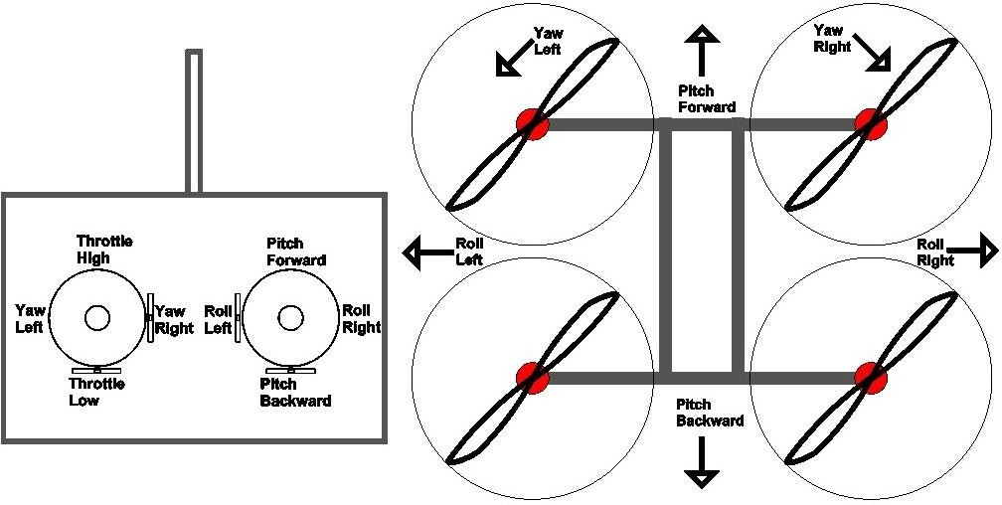

**Fig 3.6** Movement of drone.

**Pitch:** Pitch is done by pushing the right stick on transmitter forwards or backwards. This will tilt the quadcopter, resulting in forwards or backwards movement.

**Yaw**: Essentially, it rotates the quadcopter clockwise or counter clockwise. This is done by pushing the left stick to the left or to the right.

**Throttle:** Throttle gives the propellers on your quadcopter enough power to get airborne. When flying, you will have the throttle engaged constantly.

This are the four quadcopter controls which helps to navigate the drone manually. All this controls are present in the RC. The quadcopter is navigated manually by this controls i.e. roll, pitch, yaw, throttle through RC. Its flight is controlled either autonomously by onboard computers or by the remote control of a pilot on the ground or in another vehicle.

## HARDWARE WORKING:

|  |  |  |  |
| --- | --- | --- | --- |
| HARDWARE QGC (Q Ground RASPBERRY PI  SETUP control) | | | |
|  | TASK COMPLETION |  | PIXHAWK |
|  | | | |

**Fig 3.7** Hardware working process

**HARDWARE SETUP:** This includes assembling the components of a quadcopter in order to navigate it. At first the skeleton of a quadcopter is the frame or chassis is selected through which some motors and propellers are attached to it. In this we had chosen a X frame. Then the motors are attached to the frame. Motors are rated in “Kv” units, which equate to the number of revolutions per minute a motor can achieve when a 1v current is introduced to it unhindered. The higher the Kv, the faster the motor can spin. Next the propellers are fixed to the motors. The next part needed is an electronics component called an electronic speed control, or ESC. There’s an ESC for each of the four motors of the quadcopter. An ESC supplies the proper modulated current to the motors, which in turn produce correct rates of spin for both lift and maneuvering. Next the ESC’s are connected to flight controller unit. Finally, to power the quadcopter you’ll a power source, which is typically a Lithium Polymer battery. LiPo batteries use a C rating, which stands for its capacity to discharge. After assembling the components of a quadcopter, it is checked for proper connections. A transmitter and receiver are used to operate the quadcopter manually. By using RC, the motors are

armed to start the working of a quadcopter. Thus, we should ensure the quadcopter has a proper setup of hardware in order to attain it autonomously.

**QGC:** *QGroundControl* provides full flight control and vehicle setup for PX4 or ArduPilot powered vehicles. It provides Full setup/configuration of ArduPilot and PX4 Pro powered vehicles, Mission planning for autonomous flight etc. After setting up the hardware of a quadcopter it is checked for preflight checks in QGC. A preflight checklist is a list of tasks that a pilot and/or crew must perform prior to takeoff. The checklist is aircraft specific and can be arranged in sequential or segmented order. The concept of pre-flight checklists originated in 1935 as a result of a fatal accident on one of the first test flights of the B-17. The pilot had left the elevator lock on, so once the place was in the air, it didn’t respond to pitch control. During an after-action review following the incident, Boeing realized that the aircraft was too complex for pilots’ memories. It was unrealistic and unsafe to rely on pilot memory for everything that must be completed and checked prior to flight. A good preflight checklist is precise, efficient, practical and easy to use even under stress. It clearly states the item/part ex- flaps and the action ex-down. A good preflight check provides the stable and efficient working of a quadcopter.

**RASPBERRY PI**: A raspberry pi is an on-board computer. The Raspberry Pi is a low cost, credit-card sized computer that plugs into a computer monitor or TV, and uses a standard keyboard and mouse. It is a capable little device that enables people of all ages to explore computing, and to learn how to program in languages like Scratch and Python. In this the given code is dumped in order navigate the quadcopter autonomously. When the code dumped into it a connection is establish between the FCU and Raspberry pi so that the FCU can act according to the code in raspberry pi. Before dumping the code in raspberry pi, we had installed an operating system called as Ubiquity Robotics into the onboard computer. In this we had selected raspberry pi version 4 as an onboard computer.

**PIXHAWK:** The flight controller is a heart of a quadcopter. The flight controller is basically the little computer which controls the craft, and interprets the signals the transceiver sends to guide the quadcopter. In this we had chosen Pixhawk 4 has a flight controller unit. Pixhawk is an independent open-hardware project that aims to provide the standard for readily-available, high-quality and low-cost autopilot hardware designs for the academic, hobby and developer

communities. Pixhawk supports multiple flight stacks: PX4 and ArduPilot. The pixhawk controls the entire operation of quadcopter. In this the pixhawk is connected with the raspberry pi. To assure the pixhawk connection with raspberry pi there should be a message as heartbeat connected in the terminal. This message tells us that the pixhawk is connected with the raspberry pi. The pixhawk, now only performs the operation which the user given in the raspberry pi. Pixhawk is now a days most widely-used and well-tested/stable Flight controller unit. Pixhawk can be used for quadcopter and robotic arm as flight controller unit.

**TASK COMPLETION**: At last the quadcopter would execute the task which the user as given to it. The user can define any operation of his/her interest for a quadcopter to execute. Here we had developed a code for a quadcopter to perform autonomous navigation from one coordinate to other coordinate for delivery of packages. The code is written in python using ROS publishers/subscribers and topics. The code is dumped in a onboard computer- raspberry pi so that the FCU perform the given operation.

## CHAPTER 4 RESULT AND DISCUSSION

* 1. **INTRODUCTION:**

In this chapter the results are discussed and analyzed. In this we discussed the method of how a quadcopter is used for delivery purpose from one point to other point. We used a simulator called gazebo to show the movement of a quadcopter for delivery from one point to other. The gazebo simulator helps in knowing the exact working of autonomous robot by creating the real time environment. This is why most of autonomous robots are tested in the simulators before testing it in real world environment so that they don’t cause any damage. The gazebo environment includes many options in it like, we can add the sensors, obstacles and test the model.

## Gazebo:

Robot simulation is an essential tool in every roboticist's toolbox. A well-designed simulator makes it possible to rapidly test algorithms, design robots, perform regression testing, and train AI system using realistic scenarios. Gazebo offers the ability to accurately and efficiently simulate populations of robots in complex indoor and outdoor environments.

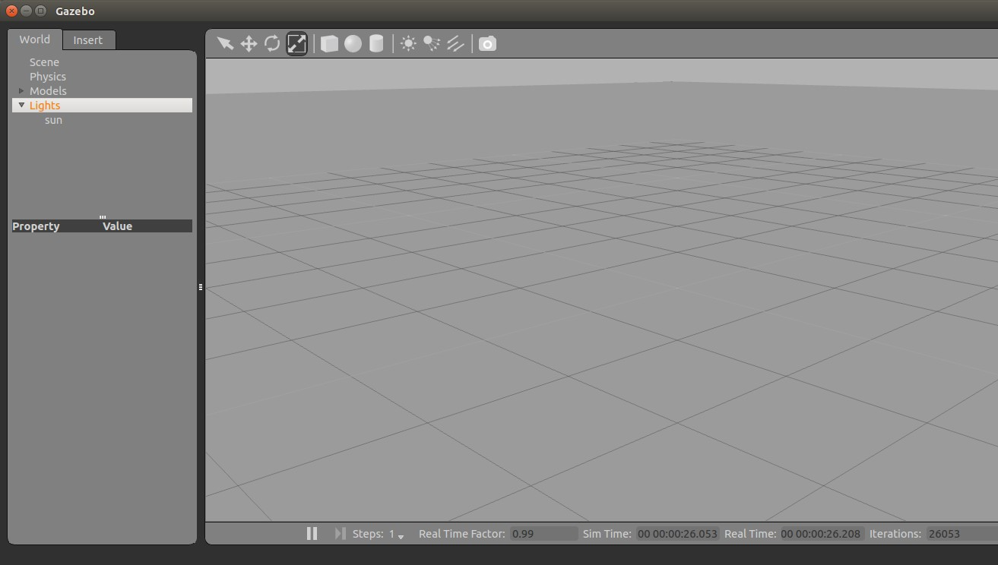

**Fig 4.1** Gazebo simulator

It is an open source 3D robotics simulator. It helps in simulating the model near to the real world. It provides realistic rendering of environments including high-quality lighting, shadows, and textures. Prototypes of the actual model are simulated in gazebo with help of ROS nodes and then the model is allowed to perform the required action to be performed in real world using the code. Simulation output helps to understand the working process of a robot perfectly. It can model sensors that "see" the simulated environment, such as laser range finders, cameras including wide-angle, Kinect style sensors, etc. It is flexible to use different sensors with the gazebo and helps in understanding their performance. At your fingertips is a robust physics engine, high-quality graphics, and convenient programmatic and graphical interfaces. Best of all, Gazebo is free with a vibrant community. We can create a real-world environment using gazebo simulator. Thus, it helps us in knowing the exact working of a autonomous robots without causing any damage in real world environment.

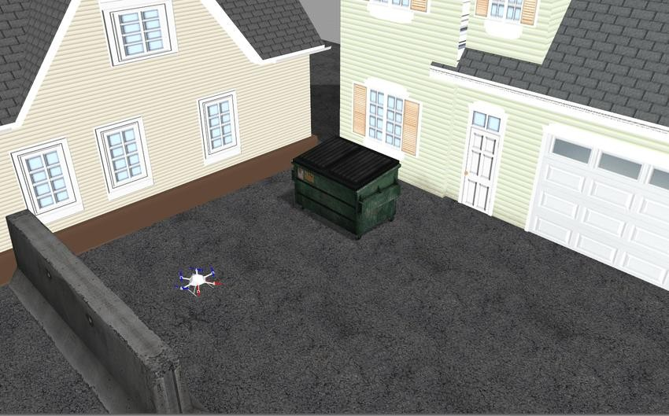

**Fig 4.2** Gazebo simulator with real world environment

Gazebo development began in the fall of 2002 at the University of Southern California. The original creators were Dr. Andrew Howard and his student Nate Koenig. The concept of a high-fidelity simulator stemmed from the need to simulate robots in outdoor environments under various conditions. As a complementary simulator to Stage, the name Gazebo was chosen as the closest structure to an outdoor

stage. The name has stuck despite the fact that most users of Gazebo simulate indoor environments. Over the years, Nate continued development of Gazebo while completing his PhD. In 2009, John Hsu, a Senior Research Engineer at Willow, integrated ROS and the PR2 into Gazebo, which has since become one the primary tools used in the ROS community. A few years later in the Spring of 2011, Willow Garage started providing financial support for the development of Gazebo. In 2012, Open Source Robotics Foundation spun out of Willow Garage and became the steward of the Gazebo project. After significant development effort by a team of talented individuals, OSRF used Gazebo to run the Virtual Robotics OSRF continues development of Gazebo with support from a diverse and active community.

## OBC Operation:

Obc stands for On-Board Computer which is the brain of the Quadcopter. OBC consists of a microcontroller having UART, SPI and I2C channels, digital and analog I/O ports, power module port, multimedia interface, GPU etc. The communication between the flight controller and the OBC is based on the UART channel. OBC is responsible for implementation of control law, processing associated with payload, data packeting activities associated with communication, monitoring load health status, handling of data storage etc. The processor needs to interface with various sensors, actuators present onboard to acquire data to perform its activities and responds accordingly through actuators. The OS of the OBC is Ubuntu with a pre- installed ROS in it. The OS is installed from a ubiquity robotics image file. For the connection to be established between the OBC and flight controller, a command of MAVROS which connects them both by a heartbeat should be executed before performing the code execution. The OBC used in this project is raspberry pi model 3.

## ANALYSIS:

* + 1. **Simulator Output Explanation:**

The output is explained using a simulator which is gazebo. The environment in gazebo can set up as the real world. Here pose represents position and orientation combined. The below shown outputs are virtual outputs which works same as in real world environment.

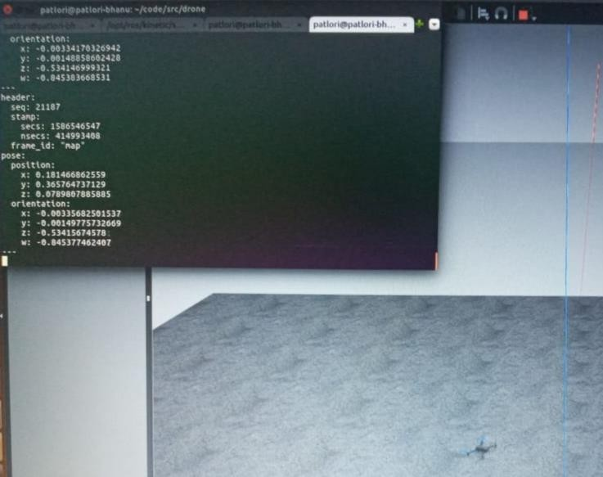

**Fig. 4.3** Initial pose of Quadcopter

Initially the quadcopter is at the origin with respect to its global and local frame. From the above fig 4.3 the initial position of the quadcopter can be noted. The position is x = 0, y = 0, z = 0.

Now the process of autonomous navigation starts with arming the quadcopter using RC. The connections are established between the flight controller and OBC such that the working mode of drone changes from manual to autonomous. Now the code to work as an autonomous delivery drone executes.

The delivery is made to be done between a point to point. In fig.4.4, now the location of the drone after executing the code is at the starting location or at the pickup point of the delivery process. Here the object to be delivered should be manually attached to the drone.

The position of coordinates is x = 0, y = 0, z = 2. This means that the drone is at a height of altitude 2m from the ground, this can be changed as per the requirement of the customer and the developer.

At the pick-up position we can place the packet on the quadcopter which needs to be delivered. The packet which is placed can be anything based upon the requirement and the purpose of the delivery. The amount or weight of the packet to be delivered depends upon quadcopter working specifications like battery capacity, payload etc.

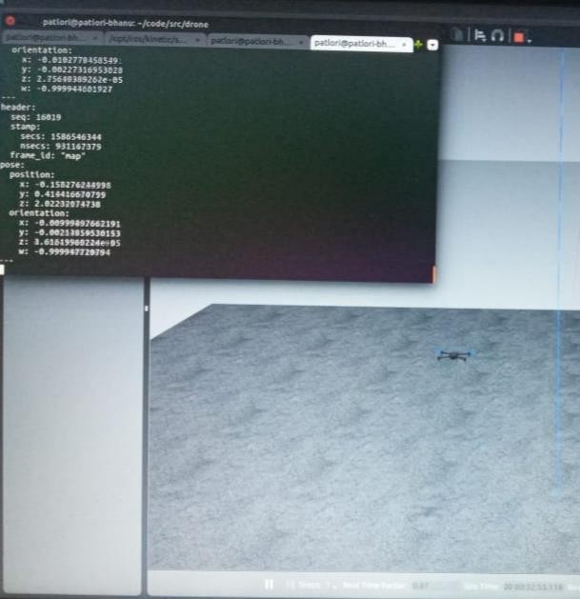

**Fig**. **4.4** Pick-up of quadcopter

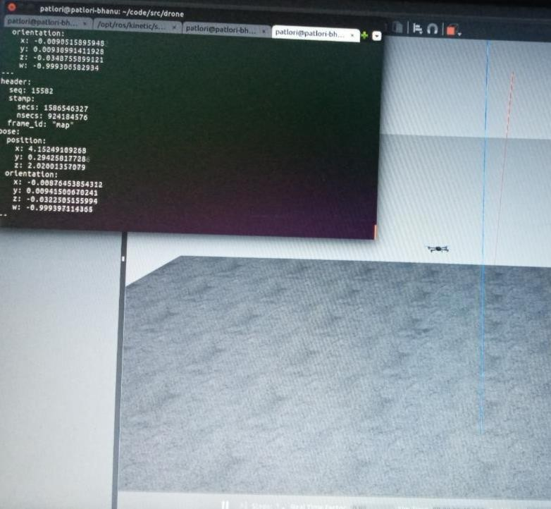

**Fig. 4.5** Delivery pose of quadcopter

In the process of code execution, the drone reaches the delivery location of the object. The drone hovers in this location such that the object to be delivered is taken from the drone. The altitude of the drone is maintained constantly over the initial path. The position of the coordinates as seen in the fig. 4.5 are x = 4, y = 0, z = 2. This means that the delivery is done between two points autonomously using a quadcopter. The distance of the delivery can be adjusted as per the battery capacity and payload of the drone.

This simulator output works the same as the real time working environment, thus it promotes a delivery between the specified locations autonomously.

## APPLICATION:

The major applications include in the fields of robotics etc.

* **Pick and Place:** With the help of End effector integrated in the Quadcopter, picking up of parts and components depending on the lift capacity of Quadcopter is possible.
* **Storage and Retrieval:** The Multipurpose end effector is capable of holding parts, this can be implied in Storage of components and retrieval of them in warehouses and inventories.
* **Remote Surveillance:** With the integrated FPV camera, the Quadcopter can be sent for stealth infiltration of enemy bases. Advanced versions of camera include Heat Vision, Thermal Cameras and Night Vision to carry out operations in various environmental conditions.
* **Disaster Relief and Rescue:** In natural calamities or any post disasters events, where human help cannot be quickly accessed, The Quadcopter can be sent for rescuing the victims and providing relief.
* **Dispersing Pesticides:** The Quadcopter can be mounted with a Pesticide dispersing canister which will spray it evenly across the farm fields.
* **Elevated Spray Painting:** The Quadcopter can be mounted with a miniature spray-painting device and can be used for painting High rise buildings.
* **Aerial Photography:** The Quadcopter can be commercially used for Aerial view of public events, sports, concerts, etc.
* **Code Enforcement and Inspection:** Building and bridge inspection without placing a person on a ladder or other potentially dangerous situation
* **Police Assistance:** The Quadcopter can be used to assist law enforcers in crowd control, mob management and surveillance.
* **Search and Rescue:** When a person goes missing in deserted locations like mountains, dense forests, artic regions, deserts, The Quadcopter will be able to locate them and intimate their location to the rescue team.
* **Animal Tracking:** In large natural habitats, animal life researchers and caretakers try to track animals whom they may have previously rescued and aftertreatment let loose in their habitat. They use a remote collar for such tracking which they tie on the animal. But the animal often gets rid of these collars which makes it very hard for the people to track them. Quadcopter can be applied in such tracking.
* **Medical Drone:** The drone will be carrying emergency first aid kits to reach quickly to the people in need.

## ADVANTAGES:

* + - The drones can fly over congested streets and take the fastest routes over buildings and other obstacles. They can deliver to remote areas that cars can’t reach efficiently.
    - They provide Reduced road congestion: Companies are looking into drone technology to do delivery tasks.
    - Reduced environmental pollution: Delivery drones are known to be more convenient than delivery trucks and are also more efficient.
    - They increase employment opportunities for manufacturing of drones.
    - Drones can fly over traffic and could, at least for last-mile delivery, prove considerably faster than humans in trucks.
    - They are more helpful in emergency cases.
    - It provides a precise deliver of package with a helicopter-like drone due to its VTOL capabilities. Unlike a plane, train or ship don’t have a set of fixed start and end locations.

## CHAPTER 5 CONCLUSION AND FUTURE SCOPE

* 1. **CONCLUSION:**

This deals with a systematic process of online delivery with an autonomous Quadcopter. Quadcopter will deliver the parcel to the customer which will reduce both time and manpower using for delivery. This process will be continued to optimize the cost of delivering products through QC so that people can use these systems more easily. The project could go in a variety of directions since the platform seems to be as flexible as we initially intended. This flexibility allows changing the functions it performs and also allows integration of any technology that would prove to be useful. The project could be enhanced as per the requirements, resources and the budget. More no of Sensors could be mounted on it thus providing more unique features. The high definitions cameras could also be installed in it. This project has clearly demonstrated the goals of proving that small scale UAVs are useful across a broad range of applications.

## FUTURE SCOPE:

This can be applied for surveillance integrating FPV camera, the Quadcopter can be sent for stealth infiltration of enemy bases. Advanced versions of camera include Heat Vision, Thermal Cameras and Night Vision to carry out operations in various environmental conditions.

By tracking the movement of UAV or an autonomous quad copter we can use them in remote areas for supply of any needs which cannot be done by man power. One such example is a tethered drone system, which provides secure communications with continuous flight, fit to serve any purpose and environment.

## REFERENCES

1. Castillo, Lozano & Dzul, “Modelling and Control of Mini-Flying Machines,” © 2005 Springer.
2. Gabriel M. Hoffmann, Haomiao Huang, Steven L. Waslander, “Quadrotor Helicopter Flight Dynamics and Control:Theory and Experiment” AIAA.
3. Michael Russell Rip, James M. Hasik, “The Precision Revolution: GPS and the Future of Aerial Warfare,” Naval Institute Press. p. 65. ISBN 1- 55750-973-5.

Retrieved January 14, 2010

1. Michael Leichtfried, Christoph Kaltenriner, Annette Mossel, “Hannes Kaufmann Autonomous Flight using a Smartphone as On-Board” ACM 978-1-4503-2106,

MoMM2013, 2-4 December, 2013

1. David Roberts, “Construction and Testing of a Quadcopter,” California Polyte McKinsey analysis; Teal Group, "World Civil Unmanned Aerial Systems Market Profile & Forecast," 2017.
2. JARUS, "Joint Authorities for Rulemaking on Unmanned Systems," [Online]. Available: <http://jarus-rpas.org/>.chnic State University, San Luis Obispo, CA, 93407, June, 2013.
3. SESAR JU, "European ATM Master Plan: Roadmap for the safe integration of drones into all classes of airspace," 2017.
4. SWARMs, "Smart and Networking Underwater Robots in Cooperation Meshes," [Online].
5. Allison Ryan and J. Karl Hedrick (2005). “A mode-switching path planner for UAV- assisted search and rescue.” 44th IEEE Conference on Decision and Control, and the European Control Conference 2005.
6. Setting Manual for Black or Blue version (Atmega168) [On-line]. Available: [http://www.kkmulticopter.kr/modea=manual](http://www.kkmulticopter.kr/modea%3Dmanual)
7. RobMoSys, "Composable Models and Software for Robotics Systems," [Online]. Available: robomys.edu.
8. Cloud4Drones, "Efficient drone-based inspection of infrastructure," [Online]. Available: [http://www.cloud4drones.eu/the-project.](http://www.cloud4drones.eu/the-project)
9. SWARMs, "Smart and Networking Underwater Robots in Cooperation Meshes," [Online]. Available: <http://www.swarms.eu/>
10. AIRMES, "Cooperative Heterogeneous drones," [Online]. Available: https:/[/www.polemermedit](http://www.polemermediterranee.com/DAS-Projets/Defensesecurite-et-surete-)e[rranee.com/DAS-Projets/Defensesecurite-et-surete-](http://www.polemermediterranee.com/DAS-Projets/Defensesecurite-et-surete-) maritimes/Surveillance-et-interventionsmaritimes/AIRMES.
11. SESAR-JU, "SESAR U-Space," 2018. [Online]. Available: https:/[/www.sesarju.eu/U](http://www.sesarju.eu/U-Space)-[Space.](http://www.sesarju.eu/U-Space)
12. SESAR JU, "European ATM Master Plan: Roadmap for the safe integration of drones into all classes of airspace," 2017.

## ANNEXURE

**CODE:**

#!/usr/bin/env python

import rospy

import sys

from geometry_msgs.msg import PoseStamped

from mavros_msgs.srv import*

from mavros_msgs.srv import CommandBool, SetMode

from mavros_msgs.msg import State

current_state = State()

def FCU_callback(msg): #you should write callback before code initialisation bcoz the callback in subscriber structure needs to know what term is this

global current_state #global the variable to use it anywhere

current_state = msg #storing message headers in the variable current state

#node initialisation

rospy.init_node("off_node",anonymous = True)

local_pos_pub = rospy.Publisher('/mavros/setpoint_position/local', PoseStamped, queue_size = 10 )

state_sub = rospy.Subscriber('/mavros/state', State, FCU_callback)

arming_client = rospy.ServiceProxy('mavros/cmd/arming', mavros_msgs.srv.CommandBool)

set_mode_client = rospy.ServiceProxy('mavros/set_mode', mavros_msgs.srv.SetMode)

#service strucutre

''' variable = rospy.ServiceProxy('topic name ', msgtype.topic)

'''

rate = rospy.Rate(20)

while not current_state.connected: #'''checking if the connection is established or not

#and trying to exit the loop thats the reason we are making it to false to exit from it easily'''

print(current_state.connected)

rate.sleep()

pose = PoseStamped() #assigning posestamped data to a variable ... posestamped contains position and angular values

pose.pose.position.x = 0

pose.pose.position.y = 0

pose.pose.position.z = 2 #making pose.pose.position.z = 2 so that it can fly to 2metres

for i in range(100): #we need to send setpoints to drone to set it into OFFBOARD

local_pos_pub.publish(pose)

rate.sleep()

offb_set_mode = SetMode() #assigning the setmode type to a variable ... setmode contains data that is helpful to change modes

offb_set_mode.custom_mode = "OFFBOARD" #to know why we used .custom_mode extension read the msg files of setmode in mavros px4

arm_cmd = CommandBool() #same as set mode...but it is used to arm the drone

arm_cmd.value = True # to know wht we took .value extension read commandbool msg data in mavros

def dis_arm(): #i have written a function to disarm the drone

disarm_cmd = CommandBool()

while (current_state.armed):

arm = arming_client(False) #check the command bool msg data why we took arming_client extension and .success extension

if arm.success:

print("vechile disarmed ")

def off_board(): # function to send the drone to offboard mode

offb = set_mode_client(0,offb_set_mode.custom_mode) #check the setmode data in mavros to know why we used set_mode_clientand .mode_sent

if offb.mode_sent:

print("offboard enable")

last_request = rospy.get_rostime()

def arming(): # function to arm the drone

arm = arming_client(arm_cmd.value) #check the CommandBool data in mavros to know why we used arming client and .success

if arm.success:

print("vechile armed")

last_request = rospy.get_rostime()

last_request = rospy.get_rostime() # rospy.time.now() returns to wall clock ..that means

while not rospy.is_shutdown():

while(current_state.mode != "OFFBOARD" and (rospy.get_rostime()-last_request > rospy.Duration(5))):

off_board()

while (not current_state.armed and (rospy.get_rostime()-last_request > rospy.Duration(5))):

arming()

while (pose.pose.position.z > 1.5 and (rospy.get_rostime()-last_request > rospy.Duration(15))):

pose.pose.position.z = 0

print("Drone has reached its peak position and required time limit is satisfied")

last_request = rospy.Time.now()

local_pos_pub.publish(pose)

while (pose.pose.position.z < 0.2 and (rospy.get_rostime()-last_request > rospy.Duration(5))):

dis_arm()

rate.sleep() # it is used to sleep if the last loop is success

if __name__=='__main__':

try:

rospy.spin()

except KeyboardInterrupt:

print("Shutting down")